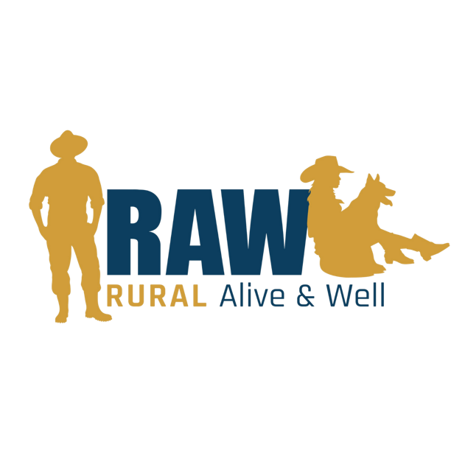

Key Information:
Position Title | Communications and Events Officer
Program/Department | Community Engagement
Location | State based, Preferred base in Northern Tasmania
Reporting To | Community Impact and Engagement Manager
Date Prepared | 9th July 2025
Approved By | CEO – Lee Whiteley
Employment Conditions | 12 Month Contract – 1.0 FTE (Preferred but negotiable)  SCHCADS Award  Level 4  Salary Packaging Benefits
Job Application Contact | Sam Gorringe  Community Impact & Engagement Manager  0487 111 479  sgorringe@rawtas.com.au

ORGANISATION OVERVIEW
Rural Alive and Well is a Tasmanian not-for-profit organisation, building mentally healthy and resilient rural communities to reduce the prevalence of suicide in ages 12 years and above.
- RAW supports Tasmanians that live in rural areas and/or that work in primary industries.
- RAW provides practical support to these people, in the form of community connection (Recognising the signs), brief interventions (Asking for help) and individual case management (Working together).
- The unique value proposition of RAW is its genuine understanding of the people it serves and the rural context that they align in.
- RAW considers itself to be the best placed to deliver its services and build authentic and trusted relationships with the people it serves, and to live its values consistently.

ABOUT RURAL ALIVE & WELL (RAW)
RAW provides practical and tangible interventions, to promote positive mental health, reduce stigma, address life stressors and provide access to specialist support services for people who live in Tasmania's rural and remote areas.

RAW is ‘non-clinical’, genuine and non-intrusive. Our service is confidential with no fees for participants.

RAW's team have a dynamic range of qualifications and lived experience, which enables one-on-one support to be authentic and personal. We work collaboratively with shared goals to get the best outcome for program participants.

RAW conversations take place where you are comfortable, for example: in the paddock, the shearing shed or your local cafes. RAW adopts a culturally sensitive, strengths-based, and collaborative approach to delivering services. Our team members are from a range of backgrounds and receive training and ongoing support to provide evidence- informed care to people.

POSITION PURPOSE
The Communications and Events Coordinator is responsible for supporting the visibility, reputation, and engagement efforts of RAW through the coordination of communications and community-facing events. The role supports the planning and delivery of public events, internal and external communications, social media, website updates, and content development. Working closely with the engagement team, the role ensures brand alignment and community relevance across all communications and events that promote RAW’s mission and values.

OPERATIONAL RESPONSIBILITIES & OBLIGATIONS
1. Community Awareness & Engagement
- Manage social media channels (Facebook, Instagram) to grow reach and engagement, ensuring timely responses and community interaction.
- Support regular and proactive communication with the community via newsletters, blogs, website content, and social media.
- Coordinate the production and distribution of engaging, brand-aligned content for campaigns, awareness initiatives, events, and fundraising efforts.
- Use visual design tools (e.g., Canva) and photography editing software (e.g., Adobe Lightroom) to create materials that support local visibility and community connection.
- Maintain up-to-date public-facing content that is reflective of program activities, partnerships, and sector priorities.

2. Stakeholder & Partnership Development
- Support the delivery of communications that strengthen relationships with partners, funders, sponsors, and community stakeholders.
- Assist with the development and coordination of sponsorship and fundraising content, including maintaining a communications pipeline.
- Contribute to third-party newsletters, sector updates, and collaborative campaigns to strengthen community and partner engagement.
- Liaise with print, media, and supplier partners to coordinate the production and distribution of branded content and resources.

3. Program & Event Coordination
- Support communications requirements for events and community engagement activities, including promotions, invitations, event collateral, and post-event updates.
- Work collaboratively with outreach and engagement teams to ensure regional activities are well-supported with timely and effective communications.
- Assist with photographic and video content capture at events and local activities, where appropriate.
- Assist with planning, promotion, and delivery of RAW events and community activities across Tasmania.
- Coordinate invitations, registrations, logistics, and materials for events including field days, regional expos, and awareness campaigns.
- Work closely with regional staff to ensure events are culturally appropriate, accessible, and aligned with local needs.
- Provide hands-on event support, including photography, set-up/pack-down, and community liaison.

4. Strategic and Operational Communications Support/Administration
- Manage website updates and collaborate with external provider (THINK) to ensure functionality, relevance, and accuracy.
- Oversee the Raisely platform to support donation management, newsletter distribution, campaign delivery, and subscriber engagement.
- Develop and maintain a digital asset and resource library for internal and external use, ensuring materials remain current, accessible, and brand-aligned.
- Coordinate print and digital resource ordering, working with suppliers to manage stock and invoicing.
- Support internal staff communications, including coordination of a regular internal newsletter.

5. Monitoring, Evaluation & Reporting
- Monitor and report on social media, website, email engagement, and campaign analytics to inform continuous improvement and strategic alignment.
- Track communications-related performance metrics and contribute insights to support organisational reporting and planning.
- Maintain accurate records of stakeholder communications and audience engagement through relevant tools and platforms.

6. Organisational Contribution & Compliance
- Work collaboratively with other RAW team members across program areas to support integrated service delivery and a positive team culture.
- Ensure all activities comply with workplace health and safety, privacy, child safety and organisational risk policies.
- Travel extensively across regional and remote locations, including out-of-hours work as required to attend community events and outreach activities.
- Undertake other reasonable duties within scope and capability as directed by the Community Impact and Engagement Manager.

SELECTION CRITERIA
Essential Requirements:
- Demonstrated passion for using communications to support the mental health and wellbeing of rural and remote communities.
- Proven experience in communications, event coordination, or community-facing roles in the not-for-profit, health, or community services sector.
- Strong understanding of digital engagement strategies, including social media, websites, and e-newsletters.
- Proficiency in using design and communications tools such as Canva, Mailchimp or Raisely, and website CMS platforms.
- Experience developing clear, accessible, and engaging content tailored to a range of audiences and platforms.
- Ability to manage multiple communication projects simultaneously and meet deadlines with minimal supervision.
- Strong organisational skills with attention to detail and the ability to maintain structured systems for content and resources.
- Excellent written and verbal communication skills, with the ability to translate complex ideas into community-friendly messaging.
- Demonstrated ability to work collaboratively with internal teams, suppliers, and community stakeholders.
- Current Tasmanian Driver’s Licence, National Police Check, and Working with Vulnerable People registration (child-related).

Desirable Requirements:
- Minimum 3 years’ experience in a communications and/or events role, and/or relevant qualifications in communications, marketing, or related fields.
- Lived experience or strong understanding of rural, remote, or primary industry communities.
- Familiarity with fundraising or sponsorship communications and supporter engagement strategies.
- Experience in photography, video editing or managing visual media libraries.
- Awareness of the role of communications in promoting mental health, wellbeing, and suicide prevention.
- Experience working in the not-for-profit or community services sector.
- Basic knowledge of interpreting analytics to inform communication strategies.
- Training in Mental Health First Aid, suicide prevention, or trauma-informed practice (desirable but not essential).

WORKING ENVIRONMENT
Workplace Diversity
RAW is committed to valuing and respecting each other as colleagues and peers. We value the fact that individuals bring different ideas, skills and backgrounds to their work in this organisation, and we recognise that people have different needs and aspirations.

We value the diverse backgrounds, skills and contributions of all employees and treat each other and our customers with respect. We also value those who have a lived experience of mental health issues. We do not tolerate discrimination, harassment or bullying in the workplace.

Occupational Health and Safety
RAW is a smoke free work environment. Smoking is prohibited in all workplaces including vehicles. RAW is committed to high standards of performance in respect to occupational health and safety. All employees are expected to participate in maintaining safe working conditions and practices.

All employees are required to comply with the Workplace Health and Safety Act 1995, section 16 “Duties of Employees”. The Workplace Health and Safety Act 1995 can be found at, http://www.thelaw.tas.gov.au

GOVERNANCE STRUCTURE
RAW is governed by a 9 member skills-based Board of Governance that has a strong balance of professional, agricultural and community experience.

RAW’s operations are managed by its Executive Team who have day-to-day responsibility for its programs and activities.

Child Safety Standards
RAW has a commitment to ensure we provide professional, safe and enjoyable environments to children and young people who participate in our programs.

The Executive Team of our organisation are responsible for undertaking recruitment and ensuring that our processes and systems are robust and thorough, as well as being communicated and understood internally. Our recruitment process is a 5-step process and includes meeting and engaging with a variety of key people from across the organisation as well as completing thorough verification checks.

As part of our comprehensive recruitment process, we ensure that all safety and legislative checks such as working with children checks, Criminal background checks, employment and personal reference checks are completed to ensure anyone working for the RAW is fit for the role they are employed in, prior to commencing employment.

RAW takes the safety of children and young people very seriously and reviews all processes and procedures in line with current state and federal legislation.

